Mid-Project Progress Report
  - Deadline: 26/7/2026 @ 23:59
[Total Mark for this Project is 6]

IT475
Decision Support Systems
Students Details:
CRN: 50271
Name: Abdulaziz Almutawa |  | ID: S230008451
Name: Abdulmajeed Alanazi |  | ID: S230044376
Name: Abdullah Almaidan |  | ID: S230058671
Name: Faisal Alalawi |  | ID: S230026151
Name: Sabri Aldammas |  | ID: S230054237

Instructions:
- You must submit two separate copies (one Word file and one PDF file) using the Assignment Template on Blackboard via the allocated folder. These files must not be in compressed format.
- It is your responsibility to check and make sure that you have uploaded both the correct files.
- Zero mark will be given if you try to bypass the SafeAssign (e.g. misspell words, remove spaces between words, hide characters, use different character sets or languages other than English or any kind of manipulation).
- Email submission will not be accepted.
- You are advised to make your work clear and well-presented. This includes filling your information on the cover page.
- You must use this template, failing which will result in zero mark.
- You MUST show all your work, and text must not be converted into an image, unless specified otherwise by the question.
- Late submission will result in ZERO mark.
- The work should be your own, copying from students or other resources will result in ZERO mark.
- Use Times New Roman font for all your answers.

Question One
6 Marks
Learning Outcome(s):
CLO1: Demonstrate an understanding of the concepts of decision analysis and decision support systems (DSS), including probability, modelling, decisions under uncertainty, and real-world problems.
CLO3: Recognize DSS evolution to the current state of analytics and artificial intelligent.
CLO6:Explore ethical issues related to developing intelligent based DSS.

Student Performance Support System (SPSS)
Project Guidelines & Requirements: This project is a group-based activity that must include 5 members. The team must assign a designated Team Leader who is responsible for uploading all official project documents and acting as the primary point of contact with the course instructor. Additionally, the team leader is responsible for distributing the workload among group members and tracking their milestone progress throughout the project timeline.
Students must use Excel for data management and the Orange Data Mining workflow software to construct the decision logic models for this project.

1. Work Completed This Period
- Topic Selection: Selected a school-based decision support system (SPSS) designed to assist educators in identifying and tracking at-risk students who require immediate academic interventions.
- Criteria Definition: Established explicit threshold parameters for the rule-based decision engine, setting flags for student test scores that drop below 60% and cumulative class attendance rates that fall below 75%.
- Data Setup: Formulated a structured mock dataset in an Excel spreadsheet mapping the grades, names, and attendance records of 30 student profiles to safely evaluate algorithm performance.
- Project Workspace Setup: Initialized a shared Google Doc workspace for collaborative report authoring and established a shared cloud storage environment to begin tracking weekly progress logs.
Answer:
Topic Selection: Selected a school-based decision support system (SPSS) designed to assist educators in identifying and tracking at-risk students who require immediate academic interventions.
Criteria Definition: Established explicit threshold parameters for the rule-based decision engine, setting flags for student test scores that drop below 60% and cumulative class attendance rates that fall below 75%.
Data Setup: Formulated a structured mock dataset in an Excel spreadsheet mapping the grades, names, and attendance records of 40 student profiles — evenly distributed across all four risk outcomes (dual-threshold failure, academic-only failure, attendance-only failure, and satisfactory standing) — to safely evaluate algorithm performance ahead of receiving real student data.
Analytics Pipeline: Built the initial Orange Data Mining workflow (File → Tree → Test and Score → Predictions) and ran the first cross-validation pass. This surfaced an early data-leakage issue — two pre-computed PASS/FAIL helper columns had been included as model features, causing a trivial 1.000 score across every metric — which the team diagnosed and corrected by restricting the model to the raw Average and Attendance % features.
Dashboard Build: Constructed a live Excel dashboard tab with KPI cards (Total Students, RED/YELLOW/GREEN counts, % at risk), a risk-category bar and pie chart, a scatter-plot risk matrix showing every student against the 60%/75% threshold lines, and a weekly risk-trend line chart.
Project Workspace Setup: Initialized a shared Google Doc workspace for collaborative report authoring and established a shared cloud storage environment to begin tracking weekly progress logs.

2. One Key Decision Made During This Period
- The Decision: The team decided to construct the core decision support logic utilizing deterministic conditional threshold models and visual decision trees within the Orange software suite rather than an advanced predictive machine learning algorithm.
- The Reasoning: In educational decision support systems, transparency and auditability are critical. Teachers must understand the exact reasons why a specific student has been flagged for support. A rule-based expert system implemented via visible data workflows guarantees absolute explanation clarity, whereas a machine learning setup acts as an opaque "black box" that lacks immediate interpretability for the user.

3. One Problem Encountered
- The Problem: The early system framework focused strictly on evaluating overall final exam performance. Testing revealed that students with excellent initial exam metrics who suddenly ceased attending class went completely unflagged until it was too late for preventive intervention.
- The Resolution: We modified the core system logic to deploy a multi-criteria parallel trigger framework. The revised system monitors variables dynamically, immediately flagging a student if either their test average falls below 60% or their class attendance falls below 75%, rather than waiting for a final average.
Answer:
The Problem: The early system framework focused strictly on evaluating overall final exam performance. Testing revealed that students with excellent initial exam metrics who suddenly ceased attending class went completely unflagged until it was too late for preventive intervention. A related issue surfaced later during Orange model testing: a decision tree trained on data that included two pre-computed status columns returned a perfect 1.000 score on every evaluation metric, which was an immediate signal that the model was not really “learning” anything — it had direct access to a column that already encoded the answer.
The Resolution: We modified the core system logic to deploy a multi-criteria parallel trigger framework. The revised system monitors variables dynamically, immediately flagging a student if either their test average falls below 60% or their class attendance falls below 75%, rather than waiting for a final average. For the Orange leakage issue, we reassigned the two derived PASS/FAIL helper columns to a non-predictive (meta) role so the decision tree could only see the raw Average and Attendance % values, forcing it to rediscover the threshold logic on its own rather than shortcut through a pre-computed label.

4. Plan to Do Next
- Build Data Models: Ingest the Excel dataset matrix into Orange Data Mining and construct the visual data workflows to apply our multi-criteria rules.
- Design Dashboards: Build clear graphical visualization widgets and evaluation dashboards within the workspace so a teacher can assess class risk levels at a glance.
- Final Report & Reflection: Begin drafting the technical system design sections and collaborate on writing the individual end-of-project reflection components regarding system constraints and ethical data tracking disclosures.
Answer:
Finalize Data Models: Replace the mock dataset with real student data once it is provided, re-run the Orange workflow, and confirm the Decision Tree and Confusion Matrix results still hold on the real records.
Refine Dashboards: Polish the graphical visualization widgets and evaluation dashboard in Excel so a teacher can assess class risk levels at a glance, and validate that all KPI cards and charts recalculate correctly against the final dataset.
Final Report & Reflection: Finish drafting the technical system design sections and collaborate on writing the individual end-of-project reflection components regarding system constraints and ethical data tracking disclosures.

5. Each Group Member Input/Participation
- Member 1 (Team Leader): Responsible for coordinating instructor communications, allocating weekly project tasks, and managing file uploads. Academically, formulated the primary student performance risk rules and drafted the problem statement parameters.
- Member 2: Created, cleansed, and structured the mock student test data spreadsheet matrix in Excel for model validation.
- Member 3: Initialized the Orange Data Mining environment and mapped out the visual classification tree pipelines.
- Member 4: Managed the live document history configuration and coordinated the weekly progress log entries.
- Member 5: Conducted requirements analysis on academic intervention workflows to optimize threshold values.

Project Artifacts (Live Tracking Links)
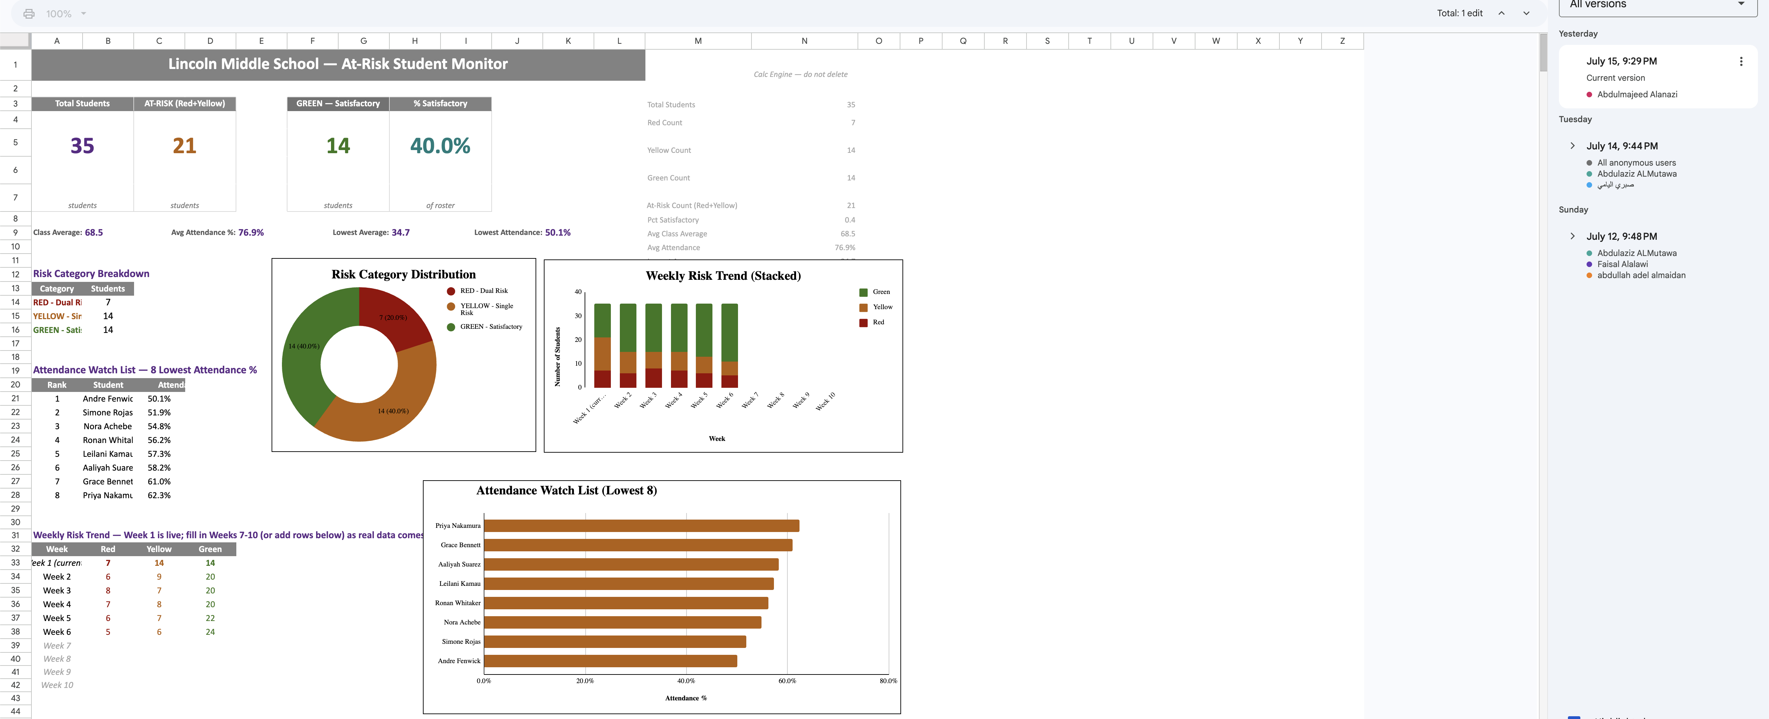
- Live Report Document (with edit history): [https://drive.google.com/drive/folders/1w1UqsEC9a0tYSdtui2Wn_u6NQdYRBv9_?usp=sharing]

- Data Workspace Repository (with progress history):
https://github.com/i3zish1-lab/IT-475
